Rymbayeva Anelya, 2 course, Lab1 – IT Infrastructure and networks

1. What is the setting for bits per second? **Answer: 9600**

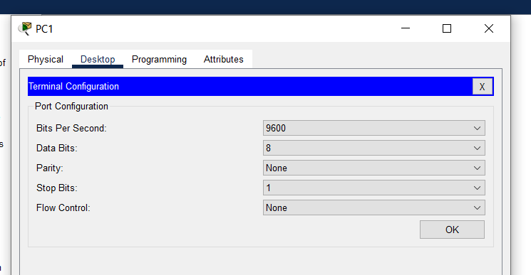

1. What is the prompt displayed on the screen?

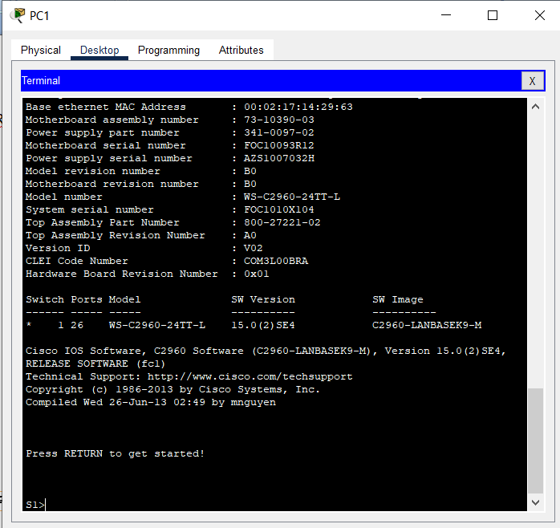

1. Which command begins with the letter “C”? **Answer: connect**

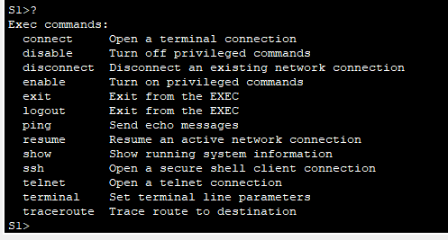

1. Type t ans then a question mark. Which commands are displayed?

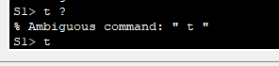

1. Type te and then a question mark. Which commands are displayed?



1. Type the question mark. What information is displayed for the enable command?

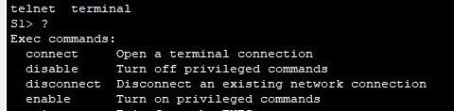

1. Type en and press the Tab key. What displays after pressing the Tab key?



1. What would happen if you typed te<Tab> at the prompt?



1. Enter the enable command and press ENTER. How does the prompt change?



1. Type the question mark. How many commands are displayed now that privileged EXEC mode is active?



1. When in privileged EXEC mode, one of the commands starting with letter “C” is configure. Type either the full command or enough of the command to make it unique. Press the <TAB> key to issue the command and press ENTER.



1. Press ENTER to accept the default parameter that is enclosed in brackets [terminal]. How does the prompt change?

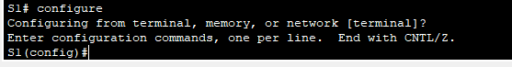

1. To return to privileged EXEC mode by typing end, exit or Ctrl+Z.

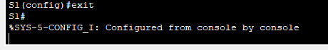

1. Type show clock at the privileged EXEC prompt. What information is displayed? What is the year is displayed?



1. Enter the command clock and press ENTER. What is the information is displayed?



1. Any time more information is needed, help can be provided by typing a space after the command and the question mark. What information is displayed?



1. Set the clock using the clock set command. Proceed through the command one step at a time. What information is being requested?



1. What would have been displayed if only the clock set command had been entered, and no request for help was made by using the question mark?



1. By using the clock set ? command, enter a time of 3:00 p.m. by using the 24-hour forat of 15:00. Check to see if more parameters are needed.

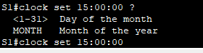

1. When finished, issue the show clock command to display the clock setting. The resulting command output should display as:

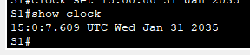

1. Issue the following commands and record the messages cl<tab>. What information returned?



1. Clock



1. Clock set 25:00:00

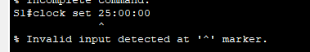

1. Clock set 15:00:00 32

